- Open SAP GUI logon pad by clicking the icon 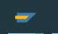
- Click the button to open the menu in the Logon window.
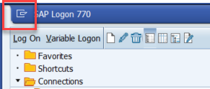
- Select the menu entry Options
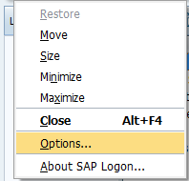
- Expand Interactive Design and then click on Control Settings. In the HTML Control section, Choose Edge (based on Chromium) from the drop down box for Browser Control. Click OK.